ROZANOV, Vasily (РОЗАНОВ, ВАСИЛИЙ) (1856-1919)

Leading writer, publicist, literary critic and philosopher in late nineteenth and early twentieth century Russia. Born in Vetluga, Russia in 1856, Rozanov remained in the provinces as a secondary school teacher until 1893, when he gained a civil service post in St. Petersburg, Russia. A prolific and original thinker, Rozanov’s path-breaking ideas on sexuality, religion and the family made him one of the most controversial figures of his day. Writing at a time when Russian journalism was highly partisan, Rozanov confounded his contemporaries by publishing contradictory views in liberal and conservative journals. Around the turn of the century, Rozanov became preoccupied with the mystical nature of sexuality in ancient pagan and Jewish religious practice. Convinced that Orthodox Christian asceticism was destroying Russian society, Rozanov began a decade-long campaign against the Russian Church’s attitude towards marriage and the family. In 1912, with the publication of his literary masterpiece, Uedinennoe (Solitaria), Rozanov transitioned to the confessional, aphoristic style that characterizes his last, and most famous, period of creativity. During the difficult years of the Russian Revolution, Rozanov and his family took refuge near the St. Sergius-Trinity Monastery, where the writer died in 1919.

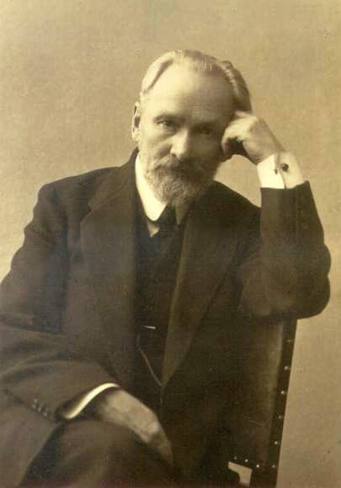
VasilyVasil’evich Rozanov was born in Vetluga, Russia on 2 May 1856 into the family of a forester. Orphaned in early adolescence, Rozanov was taken into the care of his older brother, Nikolai. In 1880, as a student at Moscow University, he married Apollinaria Suslova, a woman sixteen years his senior. Their unhappy marriage was never officially dissolved—Suslova refused to grant the writer a divorce— and in 1891 Rozanov was married again, illegally, to Varvara Butiagina in a secret church ceremony.
Rozanov self-published his first work, O ponimanii (On Understanding), in 1886 while still a secondary school geography teacher in the Russian provinces. This dense and difficult 830-page philosophical treatise was virtually ignored by the intellectual establishment. Rozanov first garnered critical attention in the early 1890s with the publication of Mesto Khristianstvo v istorii (The Place of Christianity in History) and Legenda o velikom inkvizitore F.M. Dostoevskogo (Dostoevsky’s Legend of the Grand Inquisitor). The latter work was a daring appraisal of the philosophical and religious complexity of F.M. Dostoevsky’s novel, The Brothers Karamazov.
Photograph of Rozanov, 1916.
In 1893 Rozanov received a position in the civil service in St Petersburg, Russia. In the capital city, Rozanov initially associated with a conservative Slavophile circle devoted to defending the Tsarist government and the Russian Orthodox Church against the attacks of the liberal press. As Rozanov’s philosophy of religion grew increasingly fixated on sexuality, however, he began to align himself with the decadent school surrounding Dmitry MEREZHKOVSKY (there will be a link here to the Merezhkovsky entry) and the journal Mir Isskustva (WORLD OF ART)
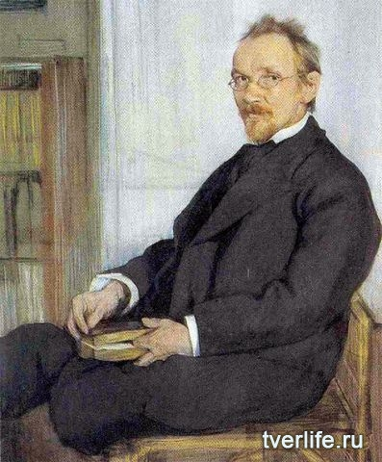
Rozanov became a full-time professional writer in 1899, when A.S. Suvorin hired him as a correspondent for the conservative weekly paper, Novoe vremia (New Times). In the same year, Rozanov published a collection of essays, Religia i Kul’tura (Religion and Culture), which testified to the writer’s increasing hostility to the Orthodox Church and his enthusiastic turn to ancient Egyptian, Greek and Jewish religious cults. Rozanov's anti-Christian polemics culminated in 1911 with the publicaton of V temnykh religioznikh luchakh (In Dark Religious Light). Rozanov claimed the 'dark face of Christ' had destroyed the possibility of joy on earth by replacing the religion of sex and the family (Judaism) with the religion of death (Christianity). In contrast to Christ's asexuality, Rozanov championed Judaism as the religion of procreation wherein God and man are physically and spiritually united in the sexual act.
Portrait of Rozanov by Leon Bakst, 1901
In Uedinennoe (Solitaria, 1912), Rozanov's most acclaimed work, religious and philosophical themes are masterfully interwoven with intimate domestic anecdotes. In this book and its sequels, Opavshie list'ia (Fallen Leaves, 1913-1915) Rozanov endeavored to record the innermost movements of thought as they occur, without the intereference of rational discourse. This groundbreaking stylistic device continued in Rozanov’s final publication, Apokalipsis nashevo vremeni (Apocalypse of Our Time, 1917-1918), a haunting masterpiece on the tragic collapse of imperial Russia.
Vasilii Rozanov moved with his family to the city of Sergeiv Posad near Moscow in 1917 to escape the tumult of the Revolution in St. Petersburg. Impoverished and starving, he suffered a stroke on 24 November 1918 and died two months later.

References and Further Reading
Despite the renaissance in Rozanov studies now occurring in Russia, there are very few English-language translations, or secondary studies, of the writer’s works.

List of Works by Rozanov in English Translation
Dostoevsky and the Legend of the Grand Inquisitor. Tr. Spencer E. Roberts. Ithaca: Cornell University Press, 1972.

Four Faces of Rozanov: Christianity, Sex, Jews, and the Russian Revolution. Tr. Spencer E. Roberts. New York: Philosophical Library, 1978.

Selections from Fallen Leaves. Tr. Boris Jakim and Laury Magnus. Chicago: The Variable Press, 2003.

Solitaria. Tr. S.S. Kotiliansky. London: Wishart & Co, 1927.

The Apocalypse of Our Time, and Other Writings. Tr. Robert Payne and Nikita Romanoff. New York: Praeger, 1977.

Selection of critical works
Crone, Anna Lisa. Rozanov and the End of Literature: Polyphony and the Dissolution of Genre in Solitaria and Fallen Leaves. Würzburg: Jal, 1978. An excellent study of the formal literary devices in Rozanov’s famous trilogy.

Mondry, Henrietta. Vasily Rozanov and the Body of Russian Literature. Bloomington, Ind: Slavica, 2010. An innovative cultural study on Rozanov’s appropriation of classic Russian literary figures.

Ure, Adam. Vasilii Rozanov and the Creation: The Edenic Vision and the Rejection of Eschatology. New York: Continuum, 2011. A much-needed study on the theological and philosophical foundations of Rozanov’s thought.

Sean Griffin, University of California, Los Angeles

Source URLs for images

Photograph
Rozanov posing for a photograph :
http://rozanov.lenin.ru/2.jpg
Portrait
Rozanov sitting :
www.tverlife.ru/img/news/43812/21550.jpg

